Quang Nguyen

CPE 409 Lab

Goals
To learn how to use interrupts in C programming language

Equipment used

Hardware
- Microchip Explorer 16 board
- PIC kit 3

Software
- MPLAB X IDE 2.00

Design Specifications
- Must act as a real time clock
  - Must write an ISR for timer 1
  - Timer 1 must be connected to the external 32.678 kHz watch crystal
  - Must store the value of seconds, minutes and hours.
  - Must display the minutes on the onboard LEDs
    - The output for the minutes will blink at the same frequency as seconds.
    - Displayed values must be in BCD
    - Seconds and hours must roll over after 59
    - Hours must roll over after 12
- Optional:
  - A press of switch S3 will shows the seconds
  - A press of switch s6 will shows the hours

Design
- Refer to figure 1 and 2 for flow diagram of the design.
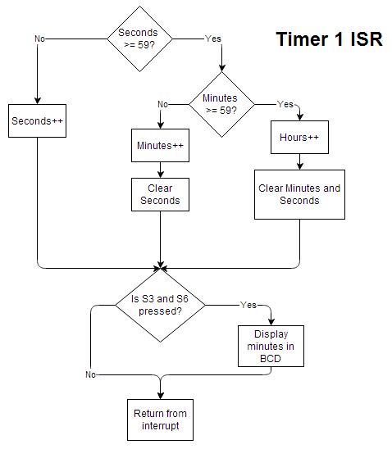
Figure 1: Flow diagram of Timer 1 ISR
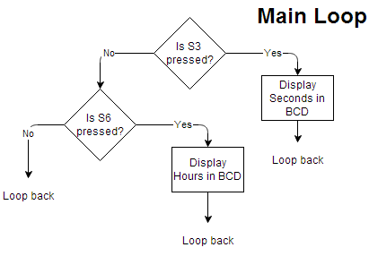
Figure 2: Flow diagram of the main loop
- Refer to the end of the report for the code of the design

Verification
- The program was allowed to run for 5 minutes.
  - During this time, the minutes display was observed to blink with a frequency of 1 Hz.
  - Also during this time, the BCD value of minutes was observed to working as expected.
  - Using a phone’s stopwatch function, a minute of the RTC was measure to be approximately equal to one minute of the stopwatch
- S3 was then pressed
  - It was observed that the value of seconds does change everyone 1 second.
  - It was observed that the BCD value of seconds was represented correctly
  - The display of seconds observed to roll over after 59 seconds.
- Minutes was allow to reach 59
  - It was observed that the display of minutes does indeed roll over after 59 minutes
- S6 was then pressed after 4 hours has elapsed
  - It was observed that the BCD value of hours does indeed represent 5.

Conclusions and Limitations
- No limitations were found
- The program works perfectly as expected.

